1. INTRODUCTION

Instructions for Preparing an Extended Abstract of Conference Proceedings

for The TOHOKU 2018
Author-1, Affiliation, Address, City, Zip, Country
E-mail:
Author-2, Affiliation, Address, City, Zip, Country
E-mail:
Key Words: Dynamics, Design, Vibration, Control, Measurement

This document provides information and instructions for preparing an extended abstract which will be included in conference proceedings for the 52th congress and meeting on Tohoku affiliate. The conference proceedings will be issued to participants at the conference. The extended abstract should be submitted as a camera-ready manuscript. Follow the instructions in this document and use this file as a template to determine the layout of your manuscripts. For preparing the camera-ready manuscript of extended abstract, all authors are requested to use white paper in A4 size (210 mm by 297 mm). The manuscript should be written in English including figures, tables and references. Maximum length of the manuscripts is 2 pages.
The whole paper (including the titles) should be set in Times New Roman (or an equivalent type face). The margins are top: 35 mm, bottom: 25 mm, left and right: 20 mm. The column width is 82 mm and the space between two columns is 6 mm.
All manuscripts should be submitted via web site. (http://www.jsme.or.jp/conference/mipe15/Extabstract/index.html) Please carefully read the instruction appeared in the web site for the details of submission procedure. Manuscripts to be submitted must be in font-embedded PDF format. Although authors are encouraged to prepare your manuscripts using this MS-Word document as a template, please convert it to the PDF format before the submission. All fonts must be embedded. Manuscripts send by e-mail attachments will not be accepted. Note that submitted manuscripts will be sent to an offset printer without modification and printed exactly as they are received.
2. TITLE PART OF MANUSCRIPTS
Title part of your manuscript must contain following three items in the following order: title of your presentation, name of author(s), and author’s affiliation. In MS Word template (this document), text box is placed at the top of the 1st page and it should contain above three items. Width of the text box must be 170 mm and its height may vary in accordance with the items’ length.
2.1 Title of your presentation
The title of your presentation should be typed in 14 pt., boldface and capital letters. It should be centered and placed at the top of the text box.
2.2 Name of author(s) and author’s affiliation
The name(s) of the author(s) should be typed in 12 pt., boldface, upper- and lower-case letters. It (They) should be centered and placed under the presentation title. There should be a 10 pt. blank space separating the presentation title from the name(s) of author(s). Author’s affiliation should comprise the department or division, university or company name, postal address including postal code, and e-mail address. All such information should be in 10 pt., italic, upper- and lower-case letters.
3. MAIN BODY OF THE TEXT
The main body of the text should be single spaced and arranged in a double-column format. Please start by providing an abstract, giving brief summary and main features of your presentation. The type size should be 10 pt.. Indent by 3 mm when starting a new paragraph.
4. MAIN HEADINGS
Main headings should be typed in capitals, boldfaced and centered. Leave 5 pt. spacing above the main headings.
4.1 Subheadings
Subheadings should be typed in boldface, upper- and lower-case letters. They should be numbered consecutively (such as 4.1, 4.2, and so on) and flush to the left-hand side of the column. Main text should begin at the next line below subheadings. Sub-subheadings should be typed in the same way as subheadings. They should be numbered such as 4.1.1, 4.1.2, and so forth.

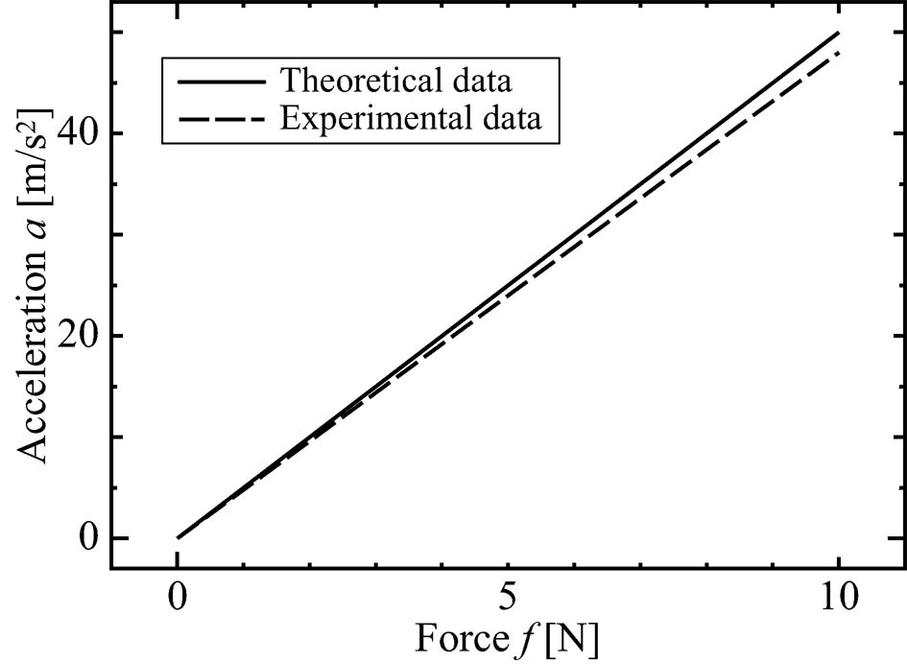

5. EQUATIONS
Equations should be numbered consecutively with the number in parentheses, and flush to the right hand side of the column, e. g.,
$m\overset{¨}{x}+c\overset{˙}{x}+\text{kx}=f$ (1)
6. FIGURES
All figures should be clear and legible to provide high-quality hard copy output. Please insert figures into the main text as near as possible to the position from which they are first referenced. Figure numbers and captions should be typed below the illustrations. The word ‘Figure’ should be shortened to ‘Fig.’ at the beginning of the figure caption. It should also be shortened to ‘Fig.’ in the text except when it begins a sentence, where it should be spelled out – ‘Figure’. See Fig. 1.
Table 1 Character size and style
Title | 14 pt. | bold
Name of authors | 12 | bold
Author’s affiliation | 10 | italic
Text | 10 | normal
Headings | 10 | bold
References | 9 | normal

7. TABLES
Type the table heading including the table number above the tables. See Table 1.
8. UNITS
Units used in the manuscript should be expressed in Standard International Units (SI).
9. CONCLUSION
Your camera-ready manuscript for the conference proceedings must be submitted via web system (http://www.jsme-tohoku.net/09_submission.htm). Please make sure that all manuscript to be submitted is in the font-embedded PDF format. In order to check the font status, open the PDF file using Acrobat Reader and select “File – Document Properties – Fonts”, then you can see the embedded fonts in your PDF file.
Fig. 1 Example of a figure.
REFERENCES
References must be numbered consecutively throughout the manuscript. They should be listed at the end of the manuscripts with the heading ‘REFERENCES’. Type size should be 9 pt.. The list of the references should contain names of all authors, title of the paper or book, journal name or publisher’s name, volume number, year, and pages. The journal names and book titles should be in italic. When referring to references in the main text, type the corresponding number in square brackets [1]. In listing the references, use the format shown below.

[1] Authors, "Paper title," Journal name, Vol. 1 No. 1 2015, pp. 1-2.
[2] Authors, Book title, Publisher's name, 2015, Country.

